**Q. Specify the following rules for given family tree -**

* **Mother(X,Y)**
* **Grandparent(X,Y)**
* **Sister(X,Y)**
* **Ancestor(X,Y)**

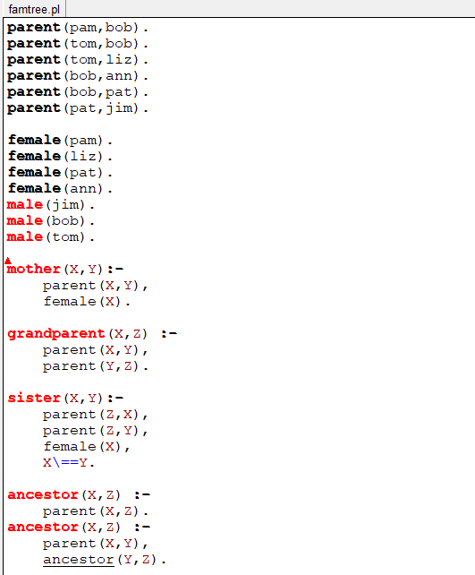

**COMMENTS / WORKING**

mother(X,Y) :- %X is mother of Y if

parent(X,Y), %X is parent of Y and

female(X). %X is female

grandparent(X,Z) :- %X is grandparent of Z if

parent(X,Y), %X is parent of Y

parent(Y,Z). %Y is parent of Z

sister(X,Y) :- %X is a sister of Y if

parent(Z,X), %Z is parent of X and

parent(Z,Y), %Z is also parent of Y and

female(X), %X is female and

X \= Y. %X and Y are different people

ancestor(X,Z) :- %Two rules for ancestor

parent(X,Z). %X is ancestor of Z if X is parent of Z

ancestor(X,Z) :-

parent(X,Y), %or X is parent of Y and

ancestor(Y,Z). %Y is parent of Z

**OUTPUT**

